NAME: SIVARANJANII.M
DATE:15.09.25 ROLL NO.:241901109

EXERCISE 7
NMAP TO DISCOVER LIVE HOSTS USING ARP SCAN, ICMP SCAN, AND TCP/UDP PING
IN TRY HACK ME PLATFORM
AIM:
In this module, we focus on discussing live hosts on a network using Nmap. Finding which systems are online is crucial before scanning ports or services to save time and avoid unnecessary network traffic. This forms the foundation for effective network mapping and security auditing.

TASK 1: INTRODUCTION
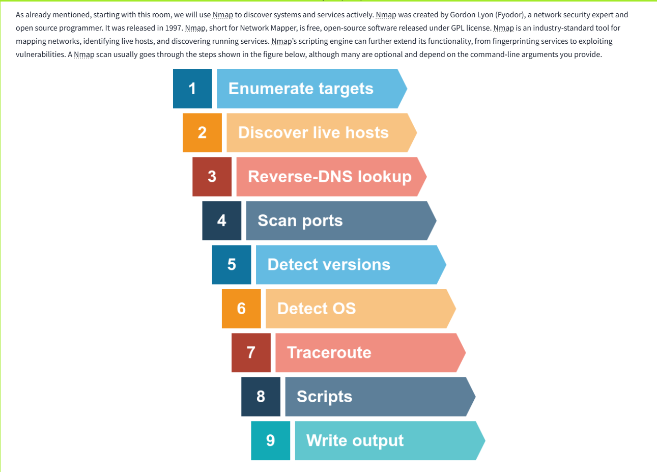

TASK 2: SUBNETWORKS
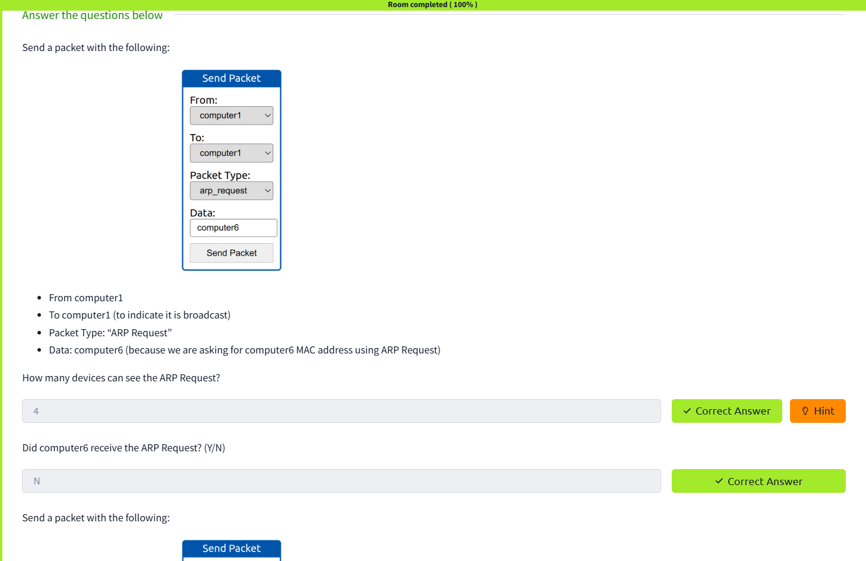

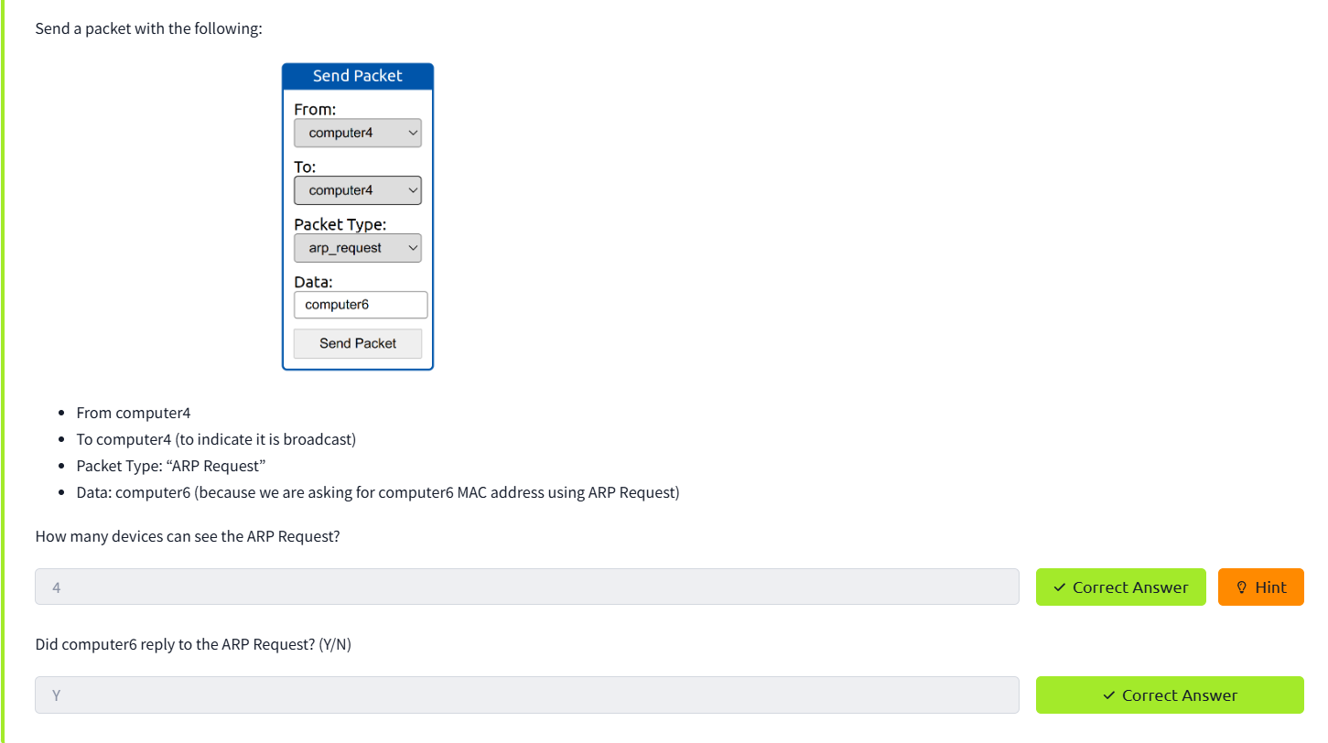

TASK 3: ENUMERATING TARGETS
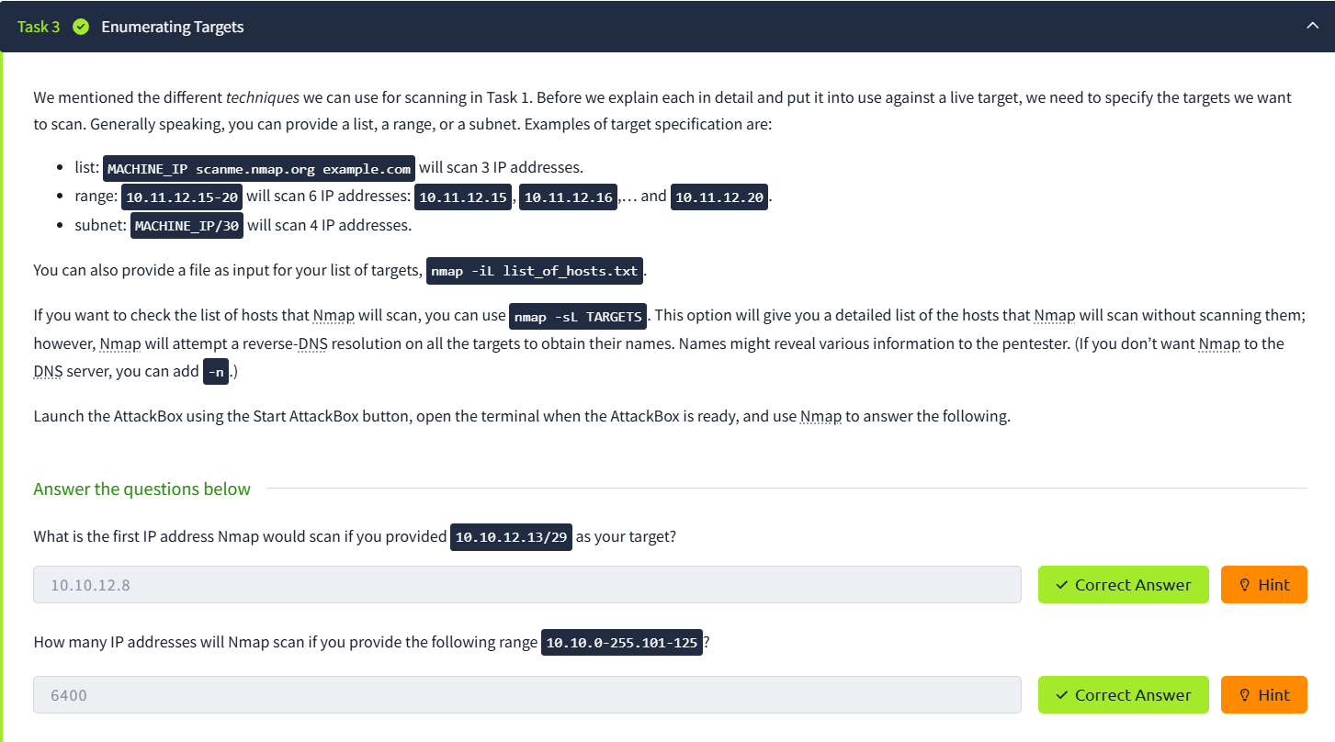

TASK 4: DISCOVERING LIVE HOSTS
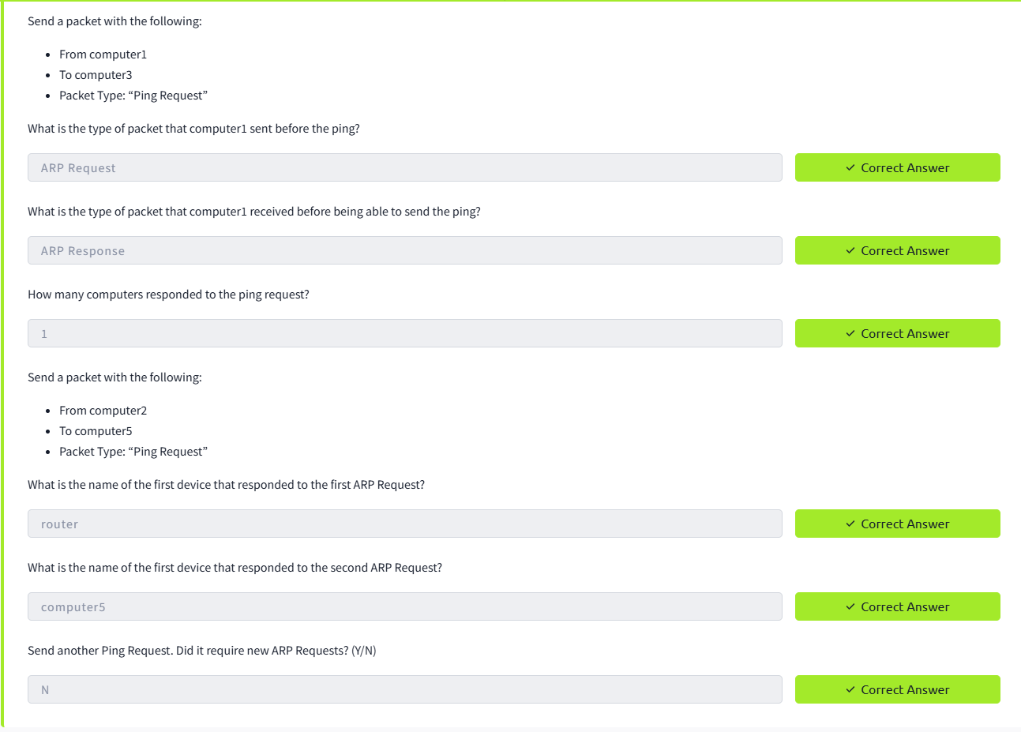

TASK 5: NMAP HOST DISCOVERY USING ARP
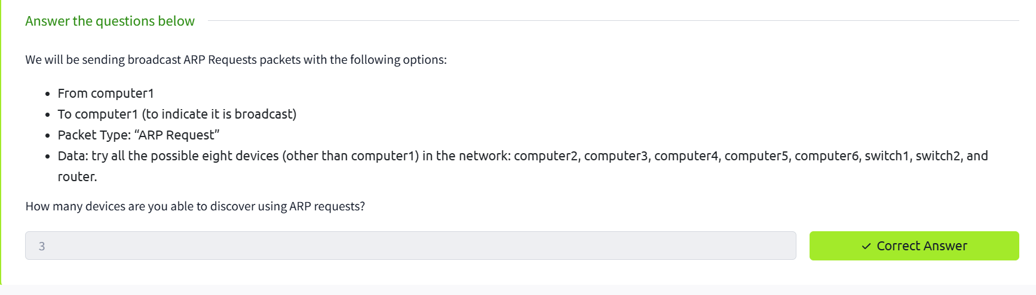

TASK 6: NMAP HOST DISCOVERY USING ICMP
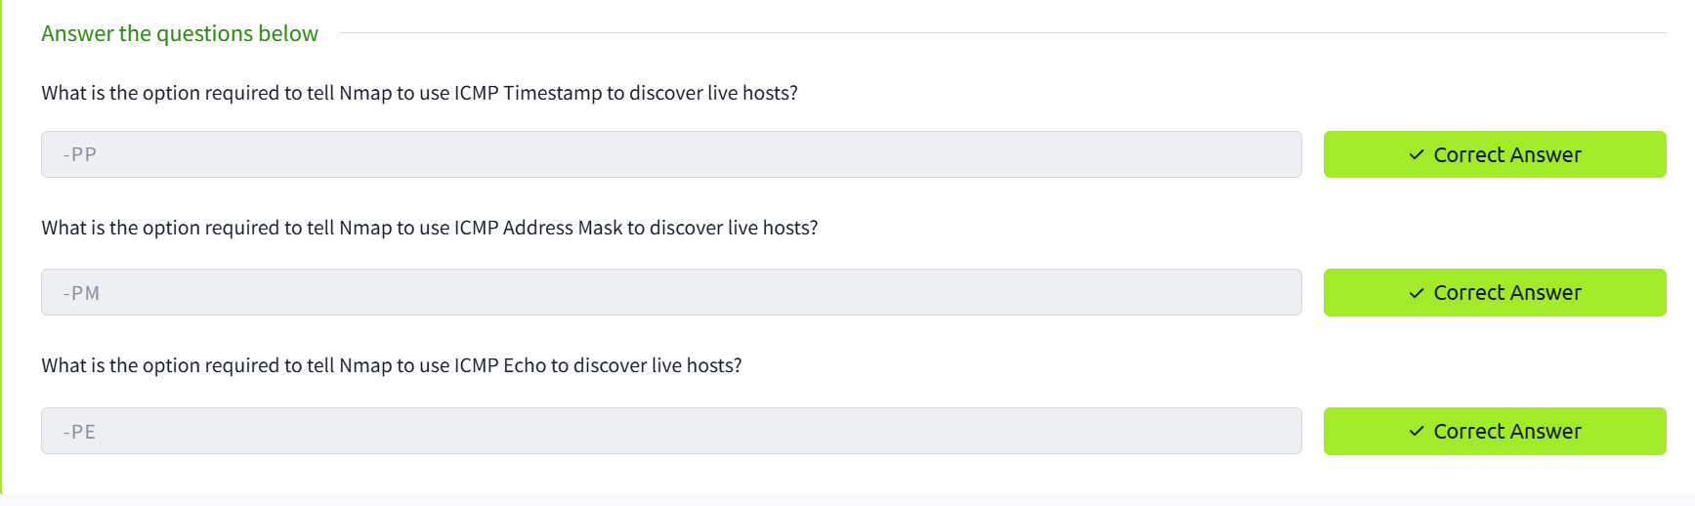

TASK 7: NMAP HOST DISCOVERY USING TCP AND UDP
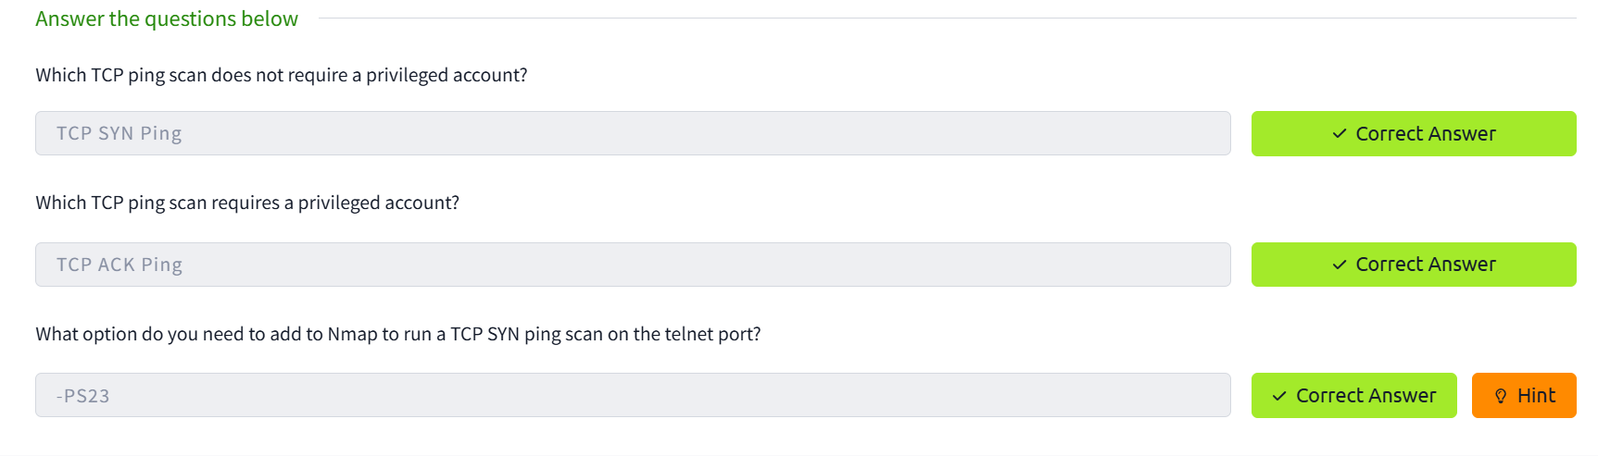

TASK 8: USING REVERSE DNS LOOKUP
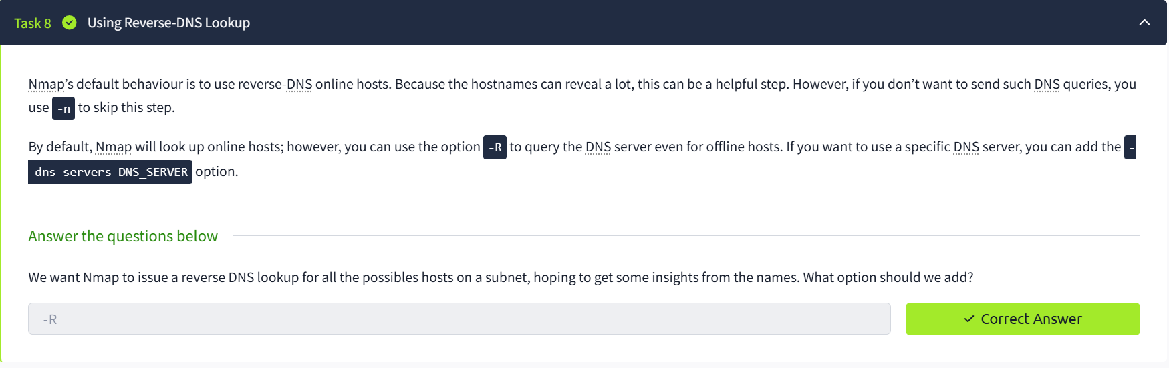

TASK 9: SUMMARY
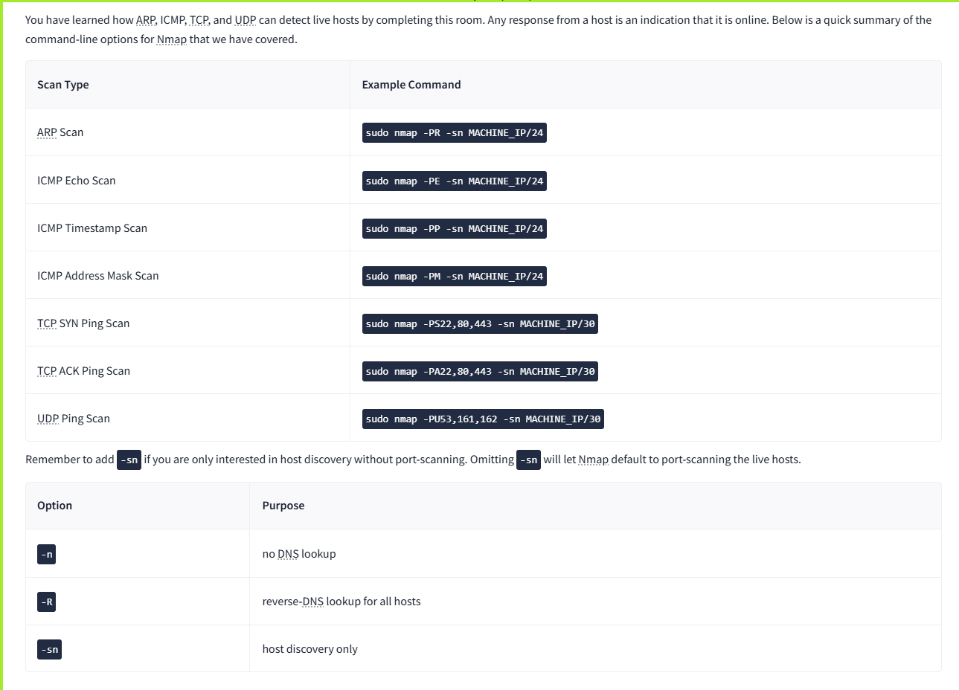

RESULT:
Nmap detects live hosts using ARP, ICMP, TCP SYN/ACK, and UDP. DNS lookups are run by default, but the -n, -R, and --dns-servers options control resolution.

